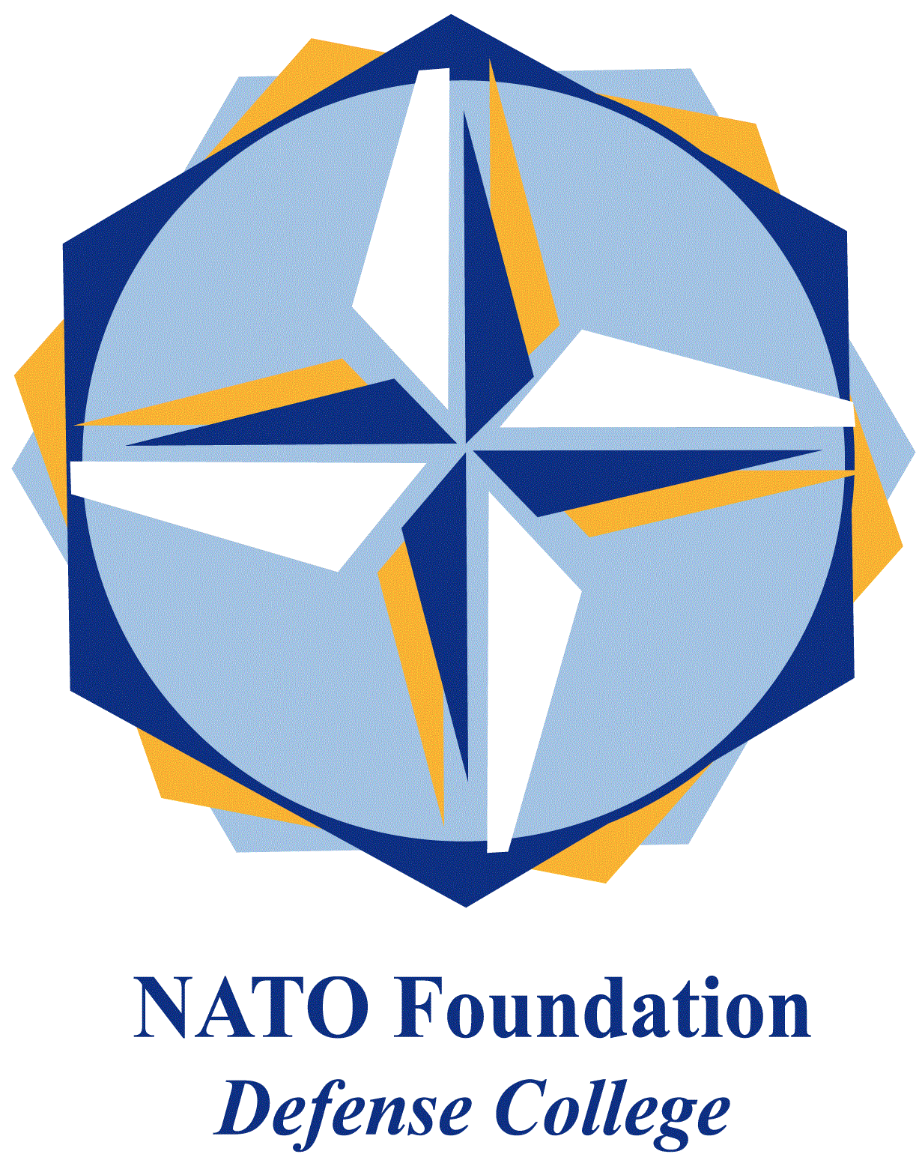
NATO DEFENSE COLLEGE FOUNDATION
STRATEGIC TRENDS
April 2015
MAGHREB
Arms continue to flow in Libya
In Libya, the political landscape has not changed significantly. Despite some progresses thanks to the efforts of the United Nations Mission in Libya (UNSMIL), the House of Representatives (HoR) in Tobruk and the General National Congress (GNC) in Tripoli are far from striking a deal. On March 2nd HoR voted to return to UN talks that resumed in the Moroccan city of Skhirate. However, the kingdom efforts to reconcile the Libyan factions produced no significant outcome; furthermore, it significantly interfered with Algerian mediation, adding more confusion and increasing the number of actors involved.
The 29th of April, Bernardino León, Special Representative of the Secretary-General for Libya, announced that he had submitted to the parties a new draft agreement and that he strived for its approval before the 17th of June (the beginning of Ramadan). Apart from the disagreement between the parties and within each faction, the main sticking point seem to be that, even if a national unity agreement would be immediately formed, it would be unable to exert any significant control on the territory, i.e. a political agreement without enforcing capabilities to dissolve the militias would be toothless.
The Islamic State strategy in Libya became more elaborated. On March 3rd, Islamist militants targeted the Bahi oil station and the Mabrouk oilfield, the latter previously attacked by DAESH last month. Security forces guarding the installations were forced to retreat. Two days later Libyan national oil company declared 11 oil fields non-operational because of the worsening of the security situation in the country. While Islamic State has not yet claimed responsibility for the oilfield attacks, it is clear that the control of oil and gas resources is important in the general strategy of the group. Despite the fact that the oil market (both legal and informal) and transportation in Maghreb are different from the Mashreq scenario, in the next future more attacks on energy infrastructures are likely to come, as DAESH will seek to profit from oil revenues in order to finance its increasing activities in the region.
The 15th of April DAESH attacked other two embassies (Morocco and South Korea) with minor damages, continuing a series of attacks that included the embassies of Egypt and Algeria, while putting further pressure on the older jihadist group Ansar al-Sharia in Libya (ASL).
In the meanwhile, the United Nations produced a report stating that the international arms embargo on Libya is almost non-existent. Released on March 2nd, the report revealed the shipping of weapons and munitions from many countries and companies to Libya. Most of these arms were also diverted from their original destinations and stolen by different Libyan militias, fuelling the current war inside the country.
Though the report states nothing new, as Libya borders are increasingly lawless and difficult to control, it represents a major blow to Egypt. In February Cairo asked for the removal of arms embargo to Libya, in order to support HoR and al-Thinni government against GNC and the Islamist faction. Stating that actually the embargo does not properly work, the report also showed evidence of the transfer of Egyptian helicopters to al-Thinni.
At the same time, HoR is not the only main recipient of arms in Libya. Prime Minister al-Thinni accused Turkey of sending weapons to GNC in Tripoli, reinforcing the narrative of a proxy war in Libya between Turkey and Qatar on one side, and Egypt, Saudi Arabia and the United Arab Emirates on the other. Nevertheless, Libyan legitimate government asked the United Nations Security Council to approve a request for military purchase in order to better contrast terrorism activities inside the country. For all these reasons, given the current regional context, it is likely that in the coming months arms will continue to flow in Libya. Any international sanction measure, such as a naval blockade, will be difficult to implement and it will not take into consideration the more intensive and complex task of the ground control of the borders.
.

